Elec A2 Question Bank
SSICTA1102_03A001E, 4
1. | An online video streaming platform allows users to upload and view videos on it. The database table VIDEO stores the information of different videos.  ID TITLE PRODUCER UPLOADDATE VIEWS  1310215 My secret menu ABC Cooking 2025-04-24 2476421  1310214 I made a mistake Pete 2025-04-23 87456  1310213 Super monkey walkthrough ep.3 Carrot 2025-04-23 561494  1310212 I survived 24 hours inside ice Mr. Feast 2025-04-22 113445622  1310211 Super monkey walkthrough ep.2 Carrot 2025-04-22 523782
 | (a) | Write a SQL command to show the number of videos produced by the producer “Carrot”.  (2 marks)
 | (b) | Write a SQL command to list the producers the number of views of their most viewed videos.  (2 marks)

[--Answer:
(a)
SELECT COUNT(*) FROM VIDEO
WHERE PRODUCER = 'Carrot'
GROUP BY PRODUCER;
(b)
SELECT PRODUCER, MAX(VIEWS) FROM VIDEO
GROUP BY PRODUCER
--]

SSICTA1102_03B002E, 4
2. | An online payment platform records user activities by storing them in a database table RECORD.  USERID DESCRIPTION AMOUNT PAYMENTDATE PAYMENTTIME  012345 Vending machine 7.5 2025-03-11 15:28:33  012345 Tom burgers 49 2025-03-11 13:21:50  011111 Bus 12 2025-03-11 10:55:30  022211 Subway 7 2025-03-10 22:50:03  012345 Bus 5 2025-03-10 22:15:15
 | (a) | List the payment history of the user "012345" by showing the description, amount, date and time of the purchase with the most recent purchase on the top. (2 marks)
 | (b) | The platform allows users to track their spending by showing the total spending of each month in a year, in the form of a line graph. Write a SQL command for user 022211 to retrieve the necessary information for the graph below. (2 marks)  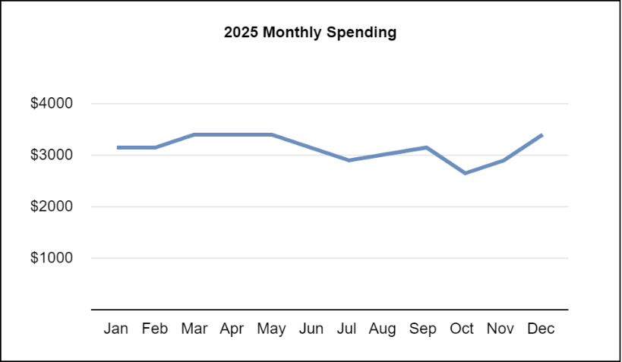

[--Answer:
(a)
SELECT DESCRIPTION, AMOUNT, PAYMENTDATE, PAYMENTTIME FROM RECORD
WHERE USERID = '012345'
ORDER BY PAYMENTDATE DESC, PAYMENTTIME DESC
(b)
SELECT MONTH(PAYMENTDATE), SUM(AMOUNT) FROM RECORD
WHERE USERID = '022211' AND YEAR(PAYMENTDATE) = 2025
GROUP BY MONTH(PAYMENTDATE)
--]

SSICTA1102_03B003E, 5
3. | An online store uses a database table ACCOUNTS to store user information.  ACCOUNTS  Field name Description Example  UID The identification code of the user A3819  NAME Name of the user Tom Chan  EMAIL The email of the user tomchan66@happymail.com  TYPE Type of membership (“Normal” or “Premium”) Normal  Primary key: UID
 | (a) | The earliest members of the store have an ID beginning with the letter "A", write a SQL command to change the member type of early members to “Premium”. (2 marks)
 | (b) | Other than character and integer types, suggest a suitable data type for TYPE. (1 mark)  ________________________________________________________________________________

[--Answer:
(a)
UPDATE ACCOUNTS
SET TYPE = 'Premium'
WHERE UID LIKE 'A%'
(b) Boolean
--]

SSICTA1102_03A004E, 4
4. | A university named Good University sends mass emails to inform students of school updates. The university uses a database table STUDENT to store student information.  STUDENT  SID NAME SEX EMAIL PROGRAMME  11551511 Chan Tai Man M 11551511@guhk.hk Computer Science  11551512 Cheung Siu Mei F 11551512@guhk.hk Psychology  11551513 Cheung Yiu Man M 11551513@guhk.hk English  11551514 Cheung Siu Man M 11551514@guhk.hk Mechanical Engineering
 | (a) | Complete the SQL command for him to list all the emails of those who are studying “Computer Science”, “Mechanical Engineering”, “Electronic Engineering” and “Computer Engineering”. (2 marks)  SELECT EMAIL FROM STUDENT  WHERE PROGRAMME IN
 | (b) | The university has changed its name. Therefore, the school has to update the domain name of students’ email addresses. Write a SQL command to list the records of the students whose email addresses contain the word "guhk.hk". (2 marks)

[--Answer:
(a)
('Computer Science', 'Mechanical Engineering', 'Electronic Engineering', 'Computer Engineering')
(b)
SELECT * FROM STUDENT
WHERE EMAIL LIKE '%guhk.hk'
--]

SSICTA1102_03B005E, 4
5. | A database table SUSPENSION stores all the water suspension cases in different regions:  SUSPENSION  Field name Description Example  CASEID The identification code for the water suspension case. 003221  SUPPLY_TYPE The suspended water supply type. Salt Water  DISTRICT The district affected. Eastern  AREA The area affected. No. 1-50 Victory Road  START The starting date and time of the case. 12-05-2024 05:20:00  END The date and time for the end of the suspension. NULL
 | (a) | Write a SQL command to list the water suspension cases along “Victory Road” with an end date in May 2024. (2 marks)
 | (b) | Write a SQL command to find the number of on-going water suspension cases in the “Eastern” District. (2 marks)

[--Answer:
(a)
SELECT * FROM SUSPENSION
WHERE AREA LIKE '%Victory Road%' AND MONTH(END) = 5 AND YEAR(END) = 2024
(b)
SELECT DISTRICT, COUNT(*) FROM SUSPENSION
WHERE DISTRICT = 'Eastern' AND END IS NULL
GROUP BY DISTRICT
--]

SSICTA1102_03B006E, 4
6. | All students in school ABC have to take their attendance by tapping their student ID card on the card reader every day when they arrive at school.  ATTENDANCE  SID RECORDDATE RECORDTIME  36122 2025-03-10 07:59:01  31638 2025-03-10 07:58:32  41291 2025-03-10 07:58:10  12331 2025-03-09 08:14:30  12244 2025-03-09 08:05:23
 | (a) | The school considers students who arrive at school after 08:00:00 late. Write a SQL command to list all the students who are late on the day '2025-03-09'. (2 marks)
 | (b) | The school would like to find the students who were late at least 3 times in March of 2025. Write a SQL command to list their SID and the number of days they were late. (2 marks)

[--Answer:
(a)
SELECT SID FROM ATTENDANCE
WHERE RECORDDATE = '2025-03-09' AND RECORDTIME > '08:00:00'
(b)
SELECT SID, COUNT(*) FROM ATTENDANCE
WHERE YEAR(RECORDDATE) = 2025 AND MONTH(RECORDDATE) = 3 AND RECORDTIME > '08:00:00'
GROUP BY SID
HAVING COUNT(*) >= 3
--]

SSICTA1102_03B007E, 5
7. | The following database table GAMES stores the information of games offered by different platforms.  GAMES  GID NAME CATEGORY PRICE PLATFORM  0001 Football 2025 sports 299 Super Games  0001 Football 2025 sports 249 The Arcade  0002 Battleground 1 fps 49 Super Games  0002 Battleground 1 fps 269 The Arcade  0003 Stream sports sports 88 Stream
 | (a) | What is the primary key of GAMES? (1 mark)  ________________________________________________________________________________
 | (b) | The platform provides a search function to allow users to input keywords to search for games. Given that the keyword from the user input is "football", write a SQL command to display all records that contain the keyword in the game name. (2 marks)
 | (c) | Write a SQL command to list all the games in the category “sports” with prices under 250 and their corresponding offering platform. (2 marks)

[--Answer:
(a)
GID + PLATFORM
(b)
SELECT * FROM GAMES
WHERE NAME LIKE '%football%'
(c)
SELECT NAME, PLATFORM
FROM GAMES
WHERE CATEGORY = 'sports' AND PRICE < 250
--]

SSICTA1102_04B001E, 9
1. | A social platform allows users to create servers containing different channels for members to chat in. Different channels are used for different purposes and can be used by different kinds of members. The following database table MESSAGES stores the messages in different channels in the server. (9 marks)  MESSAGES  CHANNELID MESSGAEID SENDERID CONTENT SENTDATE SENTTIME  general 000421 thomas123 Anybody free? 2024-02-12 21:11:42  general 000422 jeffung002 No 2024-02-12 21:12:02  game 000420 rickky Time to sleep 2024-02-12 23:59:04  game 000421 thomas123 Goodnight 2024-02-13 00:00:24  general 000423 zkull Heyyyy 2024-02-13 09:21:33
 | (a) | What is the primary key of MESSAGES? (1 mark)  ________________________________________________________________________________
 | (b) | Write a SQL command to find the number of messages sent in the channel "general" on "2024-02-13". (2 marks)
 | (c) | Write a SQL command to find all the messages sent by the user "thomas123" in the channel "general", with the most recent messages displayed first. (2 marks)
 | (d) | Write a SQL command to perform the action to the message "000421" below. (2 marks)  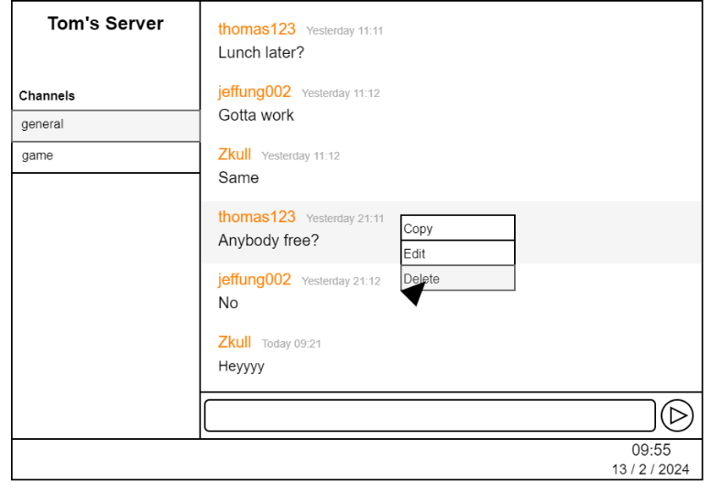
 | (e) | The platform allows admins to manage the server. Actions taken by admins are stored in a database table log. (2 marks)  AUDITLOG  LOGID USERID CONTENT ACTDATE ACTTIME  0367 thomas123 update permissions for role SQUAD 2024-02-12 19:12:42  0366 dragonmak edited channel 2024-02-12 18:40:02  0365 thomas123 deleted a message from zkull 2024-02-11 23:59:15  0364 thomas123 Updated roles for user rickky 2024-02-11 00:50:58  0363 dragonmak banned hackerg7 from the server 2024-02-11 00:50:30  Write a SQL command to list information of all bans from the server.

[--Answer:
(a) CHANNELID + MESSAGEID
(b)
SELECT COUNT(*) FROM MESSAGES
WHERE SENTDATE = '2024-02-13'
(c)
SELECT * FROM MESSAGES
WHERE SENDERID = 'thomas123' AND CHANNELID = 'general'
ORDER BY SENTDATE DESC, SENTTIME DESC
(d)
DELETE FROM MESSAGES
WHERE MESSAGEID = '000421' AND CHANNELID = 'general'
(e)
SELECT * FROM AUDITLOG
WHERE CONTENT LIKE 'banned%'
--]

SSICTA1102_04A002E, 9
2. | This study app allows users to track and manage their tasks more effectively, it uses a database table TASKS to store information on different tasks.  TASKS  Field name Description  TID Identity code of each task  TNAME Name of the task  DESCRIPTION Description of the task  PRIORITY Priority level of the task (1 means high; 2 means medium; 3 means low)  STATUS Status of the task (1 means In progress; 0 means completed)  DURATION Duration of the task in minutes, this field could be null if the task has not been completed
 | (a) | Write a SQL command to select all tasks’ names and descriptions in the TASKS table with a high priority level and currently in progress. (2 marks)
 | (b) | Write a SQL command to calculate the total duration of all tasks. (2 marks)
 | (c) | Ginny would like to find out all her tasks or descriptions including the word 'maths'. Write a SQL command to accomplish her task. (2 marks)
 | (d) | Suppose there is a table named ADMIN that the developing team can view all users’ activities. Below are some records of this table.  ADMIN  UID UNAME TID  001 Allison Fung T01  001 Allison Fung T02  002 Lisa Ma T03  003 Clarissa Tong T04  003 Clarissa Tong T05  003 Clarissa Tong T06
 |  | (i) | What is the primary key of ADMIN? (1 mark)  ____________________________________________________________________________
 |  | (ii) | Write a SQL command to count the number of tasks associated with each user in the ADMIN table who has set more than or equal to 3 tasks. (2 marks)

[--Answer:
(a) SELECT TNAME, DESCRIPTION
FROM TASKS
WHERE PRIORITY = 1 AND STATUS = 1

(b) SELECT SUM(DURATION) AS TOTAL_DURATION
FROM TASKS
WHERE DURATION IS NOT NULL

(c) SELECT TNAME, DESCRIPTION
FROM TASKS
WHERE TNAME LIKE '%maths%' OR DESCRIPTION LIKE '%maths%'

(d)
(i) UID+TID
(ii) SELECT UID, COUNT(*)
FROM ADMIN
GROUP BY UID
HAVING COUNT(*) >= 3

--]

SSICTA1102_04B003E, 11
3. | Below is a database table named DRINKS used in a bubble tea shop.  DRINKS  Field name Description Example  DID Identity code of each drink M01  DNAME Name of the drink Boba tea  PRICE Price of the drink 28  INGREDIENT1 Ingredient used in the drink Boba  INGREDIENT2 Ingredient used in the drink Fresh milk  INGREDIENT3 Ingredient used in the drink Black tea
 | (a) | Write a SQL command to find the price of the most expensive drink in the shop. (2 marks)
 | (b) | Write a SQL command to list the drinks’ names that the ingredients contain 'Boba' or 'Jelly'. (2 marks)
 | (c) | The bubble tea shop offers a 10% discount on all drinks as part of the promotional activity. Write a SQL statement to update the price of the DRINKS table. (2 marks)
 | (d) | The result of the bubble tea ordering system is saved below.  DRINKORDER  OID CID CUSTOMER DID QUANTITY TOTALPRICE ODATE  001 C11 Ms Liu M01 1 28 2023-06-28  001 C11 Ms Liu T03 1 20 2023-06-28  002 C02 Joanna S10 2 60 2023-06-29  003 C68 Morris Wan T02 1 20 2023-06-30  … … … … … … …
 |  | (i) | Write a SQL command to find the total number of orders placed. (2 marks)
 |  | (ii) | The shop is holding a membership campaign. Customers who have ordered a total of 5 drinks in June can be the golden member. Write a SQL to list the member ID. (3 marks)

[--Answer:
(a) SELECT MAX(PRICE)
FROM DRINKS

(b) SELECT DNAME
FROM DRINKS
WHERE INGREDIENT1 IN ('Boba', 'Jelly') OR INGREDIENT2 IN ('Boba', 'Jelly') OR INGREDIENT3 IN ('Boba', 'Jelly')

(c) UPDATE DRINKS
SET PRICE = PRICE * 0.9

(d)
(i) SELECT COUNT(DISTINCT OID)
FROM DRINKORDER

(ii) SELECT CID
FROM DRINKORDER
WHERE MONTH(ODATE) = 6
GROUP BY CID
HAVING SUM(QUANTITY) >= 5
--]

